***Derivación 3 puntos***

function [ r ] = diff3pts( x,y )

op=1;

h=x(2)-x(1);

for j=1:length(x)-1;

if (x(j)+h~=x(j+1))

op=0;break;

end

end

if (length(x)==length(y)&&op)

r(1)=(y(1)-4*y(2)+3*y(3))/(2*h);

for i=2:length(x)-1

r(i)=-(y(i-1)-y(i+1))/(2*h);

end

r(length(x))=(y(length(x)-2)-4*y(length(x)-1)+3*y(length(x)))/(2*h);

else

disp('No es posible utilizar el método')

r=[];

end

end

***Derivación 5 puntos***

function [ r ] = diff5pts( x,y )

op=1;

h=x(2)-x(1);

for j=1:length(x)-1;

if (x(j)+h~=x(j+1))

op=0;break;

end

end

if (length(x)==length(y)&&op)

r(1)=(-25*y(1)+48*y(2)-36*y(3)+16*y(4)-3*y(5))/(12*h);

for i=3:length(x)-2

r(i)=(y(i-2)-8*y(i-1)+8*y(i+1)-y(i+2))/(12*h);

end

r(length(x))=(-25*y(length(x)-4)+48*y(length(x)-3)-36*y(length(x)-2)...

+16*y(length(x)-1)-3*y(length(x)))/(12*h);

else

disp('No es posible utilizar el método')

r=[];

end

end

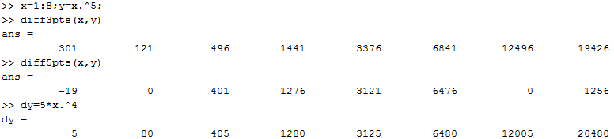

***Regla del Trapecio***

function [ F ] = inttrapecio( x0,y0,x1,y1 )

if (x1>x0)

F=(x1-x0)*(y0+y1)/2;

else

disp('Datos de entrada erróneos')

F=[];

end

end

***Regla de Simpson***

function [ F ] = intsimpson( x,y )

if (x(2)-x(1)==x(3)-x(2)&&length(x)==3&&length(y)==3)

F=(x(2)-x(1))*(y(1)+4*y(2)+y(3))/3;

else

disp('Datos de entrada erróneos')

F=[];

end

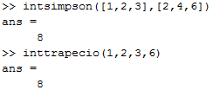end

***Ecuaciones diferenciales – Método de Taylor***

function [ W ] = ecdiftaylor( t0,tn,y0,h,n )

syms y t

F(1)=y-t^2+1; %Modificar para ecuación diferencial diferente.

for i=2:n;

F(i)=diff(F(i-1),t)+F(1)*diff(F(i-1),y);

end

N=(tn-t0)/h+1;

T=t0:h:tn;

W(1)=y0;

Tn=0;

for i=1:n

Tn=Tn+F(i)*h^(i-1)/factorial(i);

end

for i=2:N;

W(i)=W(i-1)+h*(subs(subs(Tn,W(i-1),y),T(i-1),t));

end

end

***Método de Tayor - Script para tabla:***

t0=0;tn=2;h=.2;y0=.5; %Modificar con otros valores iniciales

W2=ecdiftaylor(t0,tn,y0,h,2);

W4=ecdiftaylor(t0,tn,y0,h,4);

y=dsolve('Dy = y-t^2+1','y(0) = 0.5')

c=2+(tn-t0)/h;

t=t0:h:tn;

T=cell(c,6);

T(1,:)={'ti','Valor exacto','Orden 2','Error 2°','Orden 4','Error 4°'};

for i=2:c

T(i,1)={t(i-1)};

T(i,2)={subs(y,t(i-1))};

T(i,3)={W2(i-1)};

T(i,4)={abs(W2(i-1)-subs(y,t(i-1)))};

T(i,5)={W4(i-1)};

T(i,6)={abs(W4(i-1)-subs(y,t(i-1)))};

end

T

